Name ______________________________ HOMEWORK Feb. 15-18
Put your initials by each night that your child practiced the following:
____Monday ____Tuesday ____Thursday
*Nightly Homework*
1. Count numbers 1-75.
2. Practice assigned Sight Word list in red reading folder.

MONDAY-Say the picture and listen for the consonant blend in the word. Circle the consonant blend in the word.
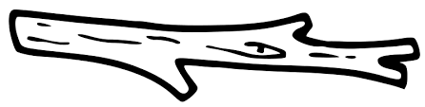  sn sl st | sn sl st | sl st sn | st sn sp | 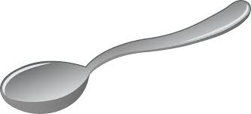  st sn sp

Label and draw three pictures that are in the -ock word family.
___ock | ___ock | ___ock

THURSDAY-Read the words.
come from if stop
from if stop come
if stop come from
stop come from if

Name the picture. Say each sound in the word. Color a circle for each sound you hear.
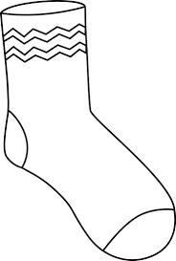

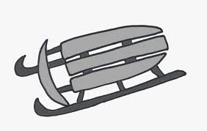

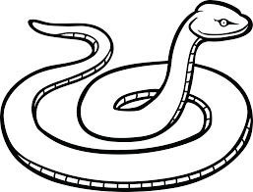

Start Right Reader Week of February 15-18
Directions: Let your child read this to you.

Words to Know
come from
if stop

Snip Stops
“Snip! Snip! Come here, Snip!” Snip nods at Meg. Snip slams to a stop. “Snip! Snip! If you come here, I can pet you.” “Snip! Snip!” begs Meg. But Snip did not step form his spot. Meg gets a step. She gets up on it. Up pops a cat! Snip did not want to step on it! Meg pets Snip. Meg hugs him, too. Snip nods.

Blend and Read: Read these words. Find these words in the story.
sled Snip step
gets but if

come stop from

Initial each night.
Mon. | Tues. | Thurs.

